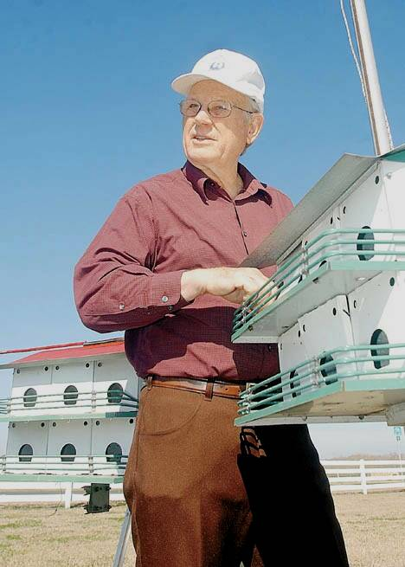

Striking a Balance
By Michael Clements
The Texas City Sun

Anyone who has attended a public meeting walked the hummingbird trail or watched a Purple Martin in Texas City has benefited from the work of Jack Cross.
Cross a resident of Texas City has lived here since 1957 and has worked to improve the community he lives in since the day he moved here. When asked why, Cross said he thinks it is important for people to do what they can to make things better. People say what they think about things, “ I try to put my thoughts into action”, he said.
Some of the actions have included serving on the Houston Galveston Area Council on Aging and the Citizens Advisory Council. He has served on the Texas City Environmental and Emergency Response Committee since its inception in 1990 and helped write the Texas City solid waste ordinances. Cross-describes himself as an environmentalists, “but I am not a radical environmentalist”.
Cross-said that he thinks man has a responsibility to preserve and protect nature. “He calls it “ striking a balance” between the needs of man and the needs of the environment. Part of that balance is to set aside areas for people to enjoy nature and to teach children about the natural world.
Along hose lines, Cross served on the Texas City Fish and Wildlife Committee for 10 years. He was instrumental in getting the city placed on the Texas Great Birding Trail.
He said it is an attitude he shares with former Mayor Charles T. “Chuck” Doyle. He and the former who Cross says he respects very much were able to get the Texas Parks and Wildlife to build a butterfly and hummingbird garden in the city. When Doyle found 13 purple martin houses, Cross and his friend A.J. Bourgeois took the responsibility of placing the houses in city parks.
Each spring the purple martins migrate from their winter homes in South America and come back to Texas City. After the birds leave, Cross helps clean out the houses and prepares them for the next year. “Its just one small step that shows that man and wildlife can live together” he said.
But nature is only one area of Cross’s concern. As a long time member of the Elks Lodge, Cross has worked hard to ensure that many area youth has the chance to better themselves. As the Lodge youth chairman for three years Cross helped coordinate scholarship programs. Under Cross’s leadership and with the help of other lodge members the local Elks lodge received national honors. Cross said it is the Elks goal to help young people through the youth program. And he added, the Elks allowed him to do something he couldn’t have done on his own.
“I couldn’t afford to give those scholarships on my own” Cross said. “The Elks give about $10 million in scholarships nationally each year”
But Cross is probably best known for his activities in local government. He can often be seen at public meetings. While he says he has great respect for Texas City’s school and government leaders, he is quick to add there are things he would like to see happen.
Cross said he is an advocate of open government. He also said that he believes that citizens should be willing to get involved. Cross said that Texas City has had some good leaders. He said that they should involve the public more than they sometimes do.
Cross said he spent the last 45 years working in his community because he loves the place he lives. He said people in Texas City are friendly and open and the community leaders are responsive to the needs of the people. He said that working for your hometown does more than make the community better.
According to Cross, there is a more personal reason for helping out.
“It gives the self satisfaction of achievement”, he said.

